(Approx. 1100 words)

NUANCES IN ITUNES FOR WINDOWS
Managing your authorized computers, managing your credit card for iTunes purchases, and converting iTunes M4A files to other sound file formats
Part 1 of a 3-part series of articles
By John Krout, By John Krout, Presenter & Newsletter Contributor
Potomac Area Technology and Computer Society
https://www.patacs.org
jkrout.apcug.presenter (at) gmail.com

Music is, for me, a lifelong entertainment source. I started listening to pop music on radio roughly when the Beatles hit the US airwaves, and I started buying LPs with paper route income about a year later. Now I own 300+ LPs and almost 500 CDs.

I am still filling in gaps in my CD collection, buying the music CD equivalents of the favorite LPs I own. I often fill such gaps at CD Cellar, a used LP, CD, and DVD/Blu Ray store in Falls Church, VA. Unfortunately, online used CD sales are usually quite pricey compared to CD Cellar. As of 2020, I have stayed away from CD Cellar due to COVID. As you can guess, many hands browse those music CDs at the store.

So, I have reverted to an older technique, buying individual songs on iTunes. When I first subscribed to iTunes, I purchased one-hit wonders from groups who never got any significant airplay for anything but one viral song. One example is the song Green-Eyed Lady by Sugarloaf, a jazzy rock staple on FM radio in the 70s. If you listened to pop music on the radio in that era, you might be able to recall some others.

I have no particular motivation to spend, say $6 or more on a used CD when I care about a specific song that will cost me $1.29 or less on iTunes. However, there is a definite improvement in sound quality on a good CD compared to an M4A file.

I tried to use iTunes on my recently purchased desktop computer to purchase two songs by Procol Harum, a very creative band from Britain which is most famous for its first hit, A Whiter Shade of Pale. Unfortunately, the songs I wanted are not one-hit wonders but are included on Procol Harum CDs that I do not own. Since the particular CDs containing the songs I wanted are out of print in the US and are quite expensive on Amazon, even used CDs, I decided to buy individual songs, at least until I can safely revisit CD Cellar for low prices on used CDs.

I ran into three issues when trying to make purchases on iTunes.

First, I buy a new computer every few years and use them until they die. That habit turns out to have caused a significant roadblock. I found that I could not authorize my 2019 desktop computer's use of iTunes since I had already hit the limit of five authorized computers for my Apple ID. Until that moment, I had no idea there was such a limit. I will explain how to work around that below. Unfortunately, the method is not intuitive.

Second, since my credit card info for purchases via iTunes expired, I no longer use that credit card number. So, I had to replace it with my current credit card info. That effort also is not exactly intuitive. You will learn how to do it in Part 2 of this article series.
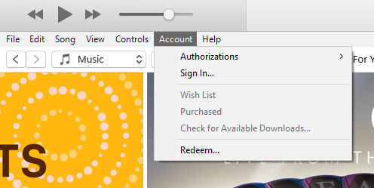Illustration 1
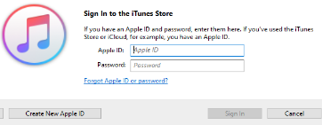Illustration 2

Finally, I found that the latest iTunes for Windows does not support converting M4A files to MP3 files by default. I discovered how to turn on that feature in iTunes. I found a non-iTunes workaround for that issue as well. You will learn about that in Part 3.

LOGGING INTO ITUNES

For the first two of these three workarounds, you will need to log into iTunes.

STEP 1. Pull down the Account menu. That appears in Illustration 1. If you are not already logged in, then choose Sign In.

If you are logged in already, you will see your name and email account in the menu. In that case, skip past Step 2 below.

STEP 2. iTunes displays the Apple ID and Password dialog window, shown in Illustration 2. Fill in the required info. When you do that, the Sign In button will become active. Tap the Sign In button. That window closes.

ITUNES AUTHORIZATION LIMIT EXCEEDED

In my case, this issue came up because each prior desktop computer on which I installed iTunes had died. If I were merely retiring a computer, then I could use iTunes on that computer to deauthorize my use of iTunes on that one computer. But the computers had died, and I could not deauthorize them individually. At the time, I had no idea iTunes imposed a ceiling.

I should emphasize that deauthorization does not prevent using iTunes to listen to songs stored on your computer. But most uses of iTunes across the Internet, including shopping for songs, will not work unless iTunes on the computer is authorized.
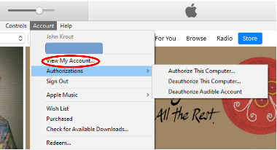Illustration 3
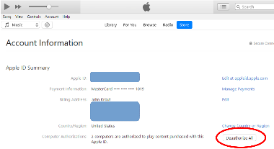Illustration 4

Apple provides a workaround for this: deauthorize all five computers (four of which are dead, in my case), using iTunes on my laptop computer, the only remaining live and authorized iTunes instance for my Apple ID.

It may seem drastic, deauthorizing even the laptop. However, keep in mind that re-authorizing iTunes on any working computer is easy using your Apple ID and password.

Here's how to do that mass deauthorization using iTunes on an authorized Windows computer. The blue boxes appearing in the next two illustrations conceal my info.

STEP 1. Pull down the iTunes Account menu again. As shown in Illustration 3, the menu now includes your login name and email account instead of the Login choice.
Note that none of the choices in the Authorizations sub-menu enable you to deauthorize all computers.

Select the View My Account choice in the Account menu. That choice is circled in Illustration 3.

STEP 2. iTunes displays the Account Information page, which is depicted in Illustration 4. Here the key button appears Deauthorize All, which is circled in the illustration. Click that button.

STEP 3. Of course, this mass deauthorization affects the instance of iTunes that you are using, not just those old dead computers. You can log in to iTunes again and choose Authorize in the menu to re-authorize the computer you used to Deauthorize All.

After I did all of that, I authorized iTunes on my 2019 desktop computer, and iTunes told me I had used two authorizations out of the five permitted by Apple. You can see that info to the left of the Deauthorize All button in the illustration.
This ends Part 1.

ABOUT THE AUTHOR: John Krout has been writing about personal computers and creative uses since the early 1980s. He frequently writes for PATACS Posts, the newsletter of the Potomac Area Technology and Computer Society, and occasionally provides demos on tech topics at PATACS meetings. He lives in Arlington, VA, with his son, many computers and cameras, and too many cats.

